Rational Materials Design for Ultrafast Rechargeable Lithium-ion Batteries

Xiaodong Chen\*

*Innovative Centre for Flexible Devices (iFLEX), School of Materials Science and Engineering, Nanyang Technological University, 50 Nanyang Avenue, 639798, Singapore*

chenxd@ntu.edu.sg

Rechargeable lithium-ion batteries (LIBs) are important electrochemical energy storage devices for consumer electronics and emerging electrical/hybrid vehicles. However, one of the formidable challenges is to develop ultrafast charging LIBs with the rate capability at least one order of magnitude higher than that of the currently commercialized LIBs. In this talk, I will present our recent development of ultrafast charging LIBs by the rational design of materials. First of all, I will discuss the protocol to rationally grow elongated titanate nanotubes with length up to tens of micrometers by a stirring hydrothermal method. The mechanical force-driven stirring process synchronously improving the diffusion and surface reaction rate of titanate nanocrystal growth in solution phase is the reason for lengthening the titanate nanotubes via an oriented attachment mechanism. This protocol to synthesize elongated nanostructures can be extended to other nanostructured systems, opening up new opportunities for manufacturing advanced functional materials for high-performance energy storage devices. Then, we will show how a robust three-dimensional network architecture with anti-aggregation property is formed for long-time cycling through the assembly of continuous one-dimensional TiO2 nanotubes, which provides direct and rapid ion/electron transport pathways and adequate electrode-electrolyte contact and short lithium ion diffusion distance comparing with other nanostructures. Finally, the future trends and perspectives for the ultrafast rechargeable LIBs are discussed. Continued rapid progress in this area is essential and urgent to endow LIBs with ultrafast charging capability to meet huge demands in the near future.

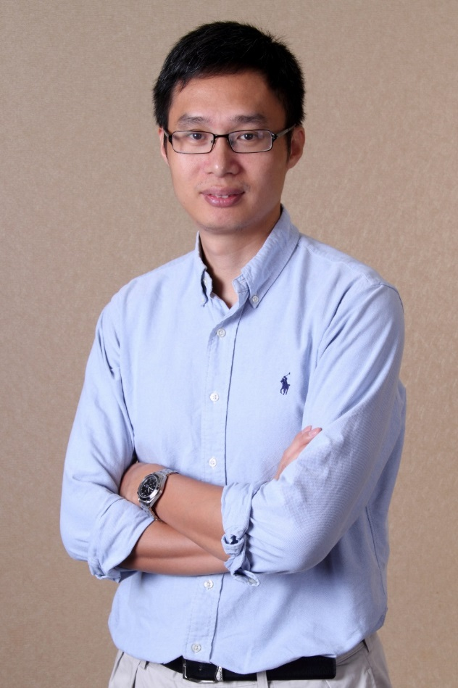Dr. Xiaodong Chen is Professor at the School of Materials Science and Engineering, Nanyang Technological University (Singapore). He received his B.S. degree (Honors) in chemistry from Fuzhou University (China) in 1999, M.S. degree (Honors) in physical chemistry from the Chinese Academy of Sciences in 2002, and Ph.D. degree (Summa Cum Laude) in biochemistry from University of Muenster (Germany) in 2006. After his postdoctoral fellow working at Northwestern University (USA), he started his independent research career as Nanyang Assistant Professor at Nanyang Technological University since 2009. He was promoted to Associate Professor with tenure in Sept 2013, then Full Professor in Sept 2016. His research interests include integrated nano-bio interface and programmable materials for energy conversion. So far, He has published over 180 scientific articles, including in *Nature Nanotech*, *Nature Chemistry*, *Nature Communications*, *JACS*, *Angew Chem*, and *Adv Mater*, and has given more than 100 invited talks/seminars. Currently, he is the Associate Editor of *Nanoscale* and Scientific Editor of *Nanoscale Horizons*. In addition, he is the member of editorial advisory board of *Advanced Materials,* *Scientific Reports,* and *Journal of Laboratory Automation.* He was selected as the Fellow of Royal Society of Chemistry in 2016. He was awarded more than ten prestigious awards and fellowships including the precious Singapore NRF Investigatorship, *Small* Young Innovator Award, Singapore NRF Fellowship, Lubrizol Young Materials Science Investigator Award, Teacher of the Year Award, the Tan Chin Tuan Exchange Fellowship, and the best PhD Dissertation award at the University of Muenster.

Dr. Xiaodong Chen is the Professor of Materials Science and Engineering and Professor of Physics and Applied Physics (by courtesy), the Founding Director of Innovative Centre for Flexible Devices (iFLEX), and Associate Chair (Faculty) of School of Materials Science and Engineering, Nanyang Technological University (Singapore). He received his B.S. degree (Honors) in chemistry from Fuzhou University (China) in 1999, M.S. degree (Honors) in physical chemistry from the Chinese Academy of Sciencesin 2002, and Ph.D. degree (Summa Cum Laude) in biochemistry from University of Muenster (Germany) in 2006. After his postdoctoral fellow working at Northwestern University (USA), he started his independent research career as Nanyang Assistant Professor at Nanyang Technological University since 2009. He was promoted to Associate Professor with tenure in Sept 2013, then Full Professor in Sept 2016. His research interests include integrated nano-bio interface and programmable materials for energy conversion. So far, He has published over 190 scientific articles, including in *Nature Nanotech*, *Nature Chemistry*, *Nature Communications*, *JACS*, *Angew Chem*, and *Adv Mater*, and has given more than 100 invited talks/seminars. Currently, he is the Associate Editor of *Nanoscale* and Scientific Editor of *Nanoscale Horizons*. In addition, he is the member of editorial advisory board of Advanced Materials,*Small Methods*, *Advanced Materials Technology*, Scientific Reports, Materials Today Energy, and *Journal of Laboratory Automation.* He was selected as the Fellow of Royal Society of Chemistry in 2016. He was awarded more than ten prestigious awards and fellowships including the precious Singapore NRF Investigatorship, *Small* Young Innovator Award, Nanyang Research Award, Singapore NRF Fellowship, Lubrizol Young Materials Science Investigator Award, NML Researcher Award, Teacher of the Year Award, the Tan Chin Tuan Exchange Fellowship, and the best PhD Dissertation award at the University of Muenster.