**Ambient Ionization Mass Spectrometry – Principles and Applications**

Renato Zenobi

Department of Chemistry and Applied Biosciences, ETH Zürich, Switzerland

and

College of Chemistry and Chemical Engineering, Xiamen University, China

“Ambient ionization mass spectrometry” is a term that describes the formation of characteristic ions from samples in their natural state, “as is”, without or with only minimal sample preparation, at ambient pressure and temperature, outside of the mass spectrometer. The earliest versions of ambient ionization were DESI (desorption electrospray ionization) and DART (“direct analysis in real time”), but by now there is a long list of methods for ambient ionization. This presentation will highlight two of these: SESI (Secondary Electrospray Ionization), where an electrospray formed from solvent only is used for post-ionization of neutral sample molecules, and DBDI (Dielectric Barrier Discharge Ionization) in an embodiment where a cold plasma is ignited inside a capillary that is directly connected to the MS inlet, such that all gas that is entering the capillary has to pass through the plasma. After introducing the concepts, a number of applications will be presented:

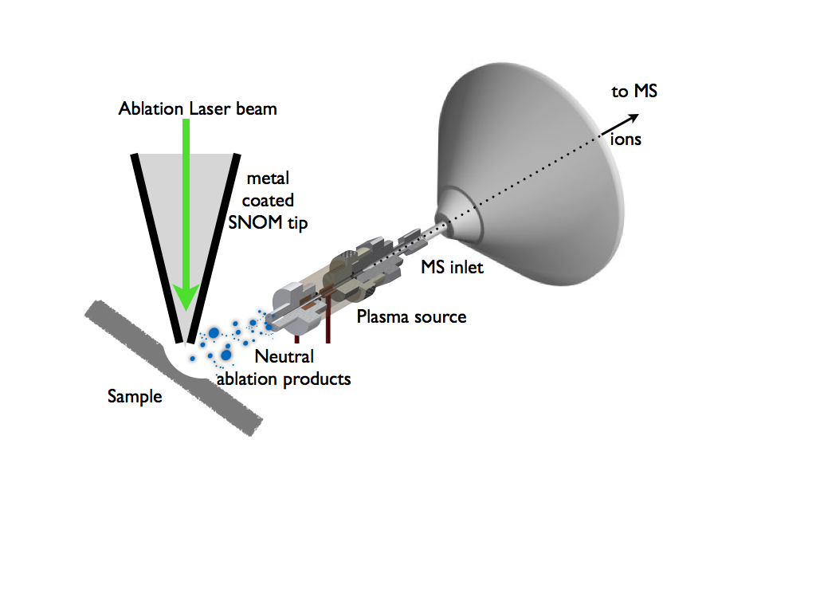- the ionization of metabolites in exhaled breath, for rapid medical diagnosis.

- the interfacing of chromatography (GC, LC) as well as solid-phase microextraction (SPME) with an ambient ionization source.

- use of a DBDI source for highly efficient ionization for detection of ablation products from sub-µm scale craters generated by near-field laser desorption (see figure).

Prof. Zenobi is recruiting motivated M.Sc. and Ph.D. students from Xiamen University to join the project in the area of near-field laser ablation – MS for naoscale chemical analysis, the topic of his 1000 talent plan held at Xiamen University.