**New Basic Activation Modes Enabled by Carbene Organic Catalysts and Rapid Synthesis of Functional Molecules**

**氮杂卡宾(NHC)催化的新型活化模式与功能分子的简洁合成**

**Yonggui Robin Chi (池永贵)**

Center for Research and Development of Fine Chemicals, Key Laboratory of Green Pesticide and Agricultural Bioengineering, Ministry of Education, Guizhou University, China (贵州大学精细化工研究开发中心)

Division of Chemistry and Biological Chemistry, Nanyang Technological University, Singapore

E-mail: [chiyg0098@126.com](mailto:chiyg0098@126.com); [robinchi@ntu.edu.sg](mailto:robinchi@ntu.edu.sg);

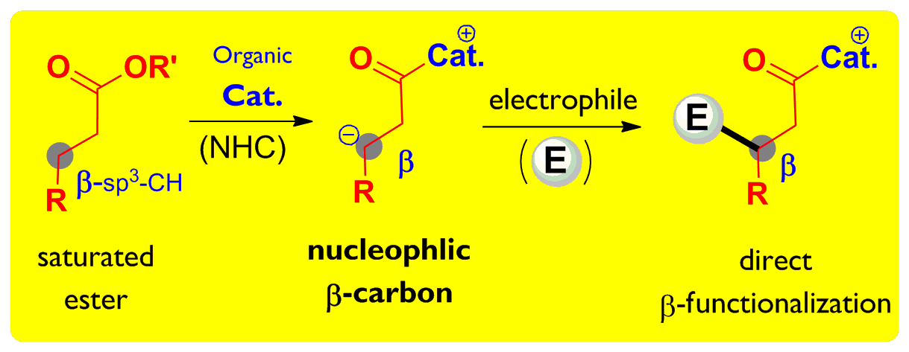The Chi laboratory is committed in state-of-art research that addresses synthetic chemistry challenges of scientific, economic, and social significance. Our essential objective is to develop fundamentally novel (organo) catalytic activation/reaction modes and synthetic strategies for the rapid (short route) synthesis of pharmaceuticals and other functional molecules that include polymer materials. Over the years, we have realized significant advancements in the design, discovery, and development of new basic activation modes enabled by N-heterocyclic carbenes (NHCs) as the key organic catalysts. With the new catalytic activation modes we hope to create new understanding of chemical reactivities and chemistry. Immediate applications of our new catalytic activation modes and synthetic strategies include concise and green processes for bioactive molecules such as valuable non-natural amino acids and their derivatives. We have also taken significant efforts in designing new molecular scaffold for applications in agriculture chemicals, and develop scalable methods for the synthesis and manufacturing of medicinal, agricultural, and other functional molecules.

Examples of our research activities include: (1) Carbene (NHC) organic catalyst-enabled activation of carboxylic esters (including the inert beta-sp3-carbon activation of saturated esters); (2)New reaction controls of aldehydes under (oxidative) carbene catalysis; (3) Cooperative catalysis combining carbene organic catalysts with other catalysts (such as transition metal catalysts, Lewis acid catalysts, and other organic catalysts); (4)Biomimetic single-electron-transfer (SET) radical reactions enabled by carbene organic catalysts; (5) Multi-disciplinary collaborative research penetrating to the conversion of biomass and sustainable raw materials, antimicrobial polymer materials, chemistry/materials for 3D printing, Chinse medicine modifications, and agricultural chemicals (antivirus and antibacterial agents for agriculture use); (6) Research efforts toward scale up and manufacturing.

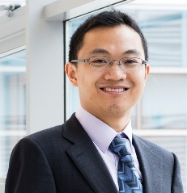Reference: *J. Am. Chem. Soc*. **2016**, *138*, DOI: 10.1021/jacs.6b00406; *J. Am. Chem. Soc*. **2015**, *137*, 2416-2419; .*Nature Commun*. **2015**, *6*, DOI: 10.1038/ncomms7207; *Nature  Commun*. **2014,** *5,* doi:10.1038/ncomms4982; ***J. Am. Chem. Soc. 2013****, 135, 8113-8116; Nature Chem*. **2013**, *5*, 835-839.

Curriculum vitae: 2012- 贵州大学特聘教授，then 千人计划/长江学者特聘教授，贵州大学“千人计划”平台负责人；2009- Assistant then Associate Professor, and guest appointment as Singapore NRF Investigator (Nanyang Technological University). 2007-2009 postdoc (UC-Berkeley); 2002-2007 PhD (UW-Madison), 1998-2002 undergraduate (Tsinghua and HKBU),

Recognitions: 教育部长江学者，科技部中青年科技创新领军人才，中组部青年千人计划，GSK Award on Sustainable Pharmaceutical Manufacturing, Singapore NRF Investigator, Nanyang Research Award, Singapore Yong Scientist Award, NRF Fellow, , Thieme Chemistry Journal Award